**Beet Seed**

**1.** Bug_001. [FE] The search is performed from the search input without any data.

**Additional description:**

The search is performed from the search input in the “Header” section with the empty request as an unlogged user. The “Знайти” button is active despite the request is not set.

**Test data:**

Build (version): 1.0.2.

Platform/OS: Windows 10 22H2.

Browsers: Google Chrome v. 131.0.6778.206 (Official Build) (64-bit), Firefox 134.0 (64-bit), Microsoft Edge 131.0.2903.112 (64-bit).

Reproduce rate: 5/5.

**Severity:**

- Minor.

**Priority:**

- Low.

**Pre-conditions:**

The “<https://avtozvuk.ua/ua>” page is opened.

**Steps to reproduce:**

1. Click on the “Пошук по назві, коду, категорії товару” search input.
2. Click on the “Знайти” button.

**Actual result:**

The search is performed from the search input in the “Header” section with the empty request.

**Expected result:**

The “Знайти” button is blocked. The search feature is not performed until a user sets at least one character.

**Attachment:**

GIF - <https://gyazo.com/94c6b28ef25c709c25f3978d0f0604cd>

**Reviewed:**Oleksii Yemelianenko.

**Assignee:**

Victor Babak.

**2.** Bug_002. [FE] The “Зворотній дзвінок” modal is not opened from the “Header” section after clicking on the “Handset” icon.

**Additional description:**

The “Uncaught ReferenceError: showNextelButton is not defined at HTMLButtonElement. Onclick“ error is displayed in the “Console” section of the “Chrome” Dev Tools after clicking on the “Handset” icon.

N.B.: This feature is not either called from the “Footer” section.

**Test data:**

Build (version): 1.0.2.

Platform/OS: Windows 10 22H2.

Browsers: Google Chrome v. 131.0.6778.206 (Official Build) (64-bit), Firefox 134.0 (64-bit), Microsoft Edge 131.0.2903.112 (64-bit).

Reproduce rate: 7/7.

**Severity:**

- Critical.

**Priority:**

- Medium.

**Pre-conditions:**

The “<https://avtozvuk.ua/ua>” page is opened. The “Chrome” Dev tools are opened in the “Console” section.

**Steps to reproduce:**

1. Hover over the “Handset” icon in the “Header” section.
2. Click on the “Зворотній дзвінок” button.

**Actual result:**

The “Зворотній дзвінок” modal is not opened from the “Header” section after clicking on the “Handset” icon.

**Expected result:**

The “Зворотній дзвінок” modal is opened from the “Header” section after clicking on the “Handset” icon.

**Attachment:**

GIF - <https://gyazo.com/3a5ad83194b0c821ab7f7ce17944c5d6>

**Reviewed:**Oleksii Yemelianenko.

**Assignee:**

Victor Babak.

**3.** Bug_003. [FE] The request is sent from the “Login” page without filling all required fields.

**Additional description:**

The “Увійти” button is active despite the “Email” field is not filled.

**Test data:**

Build (version): 1.0.2.

Platform/OS: Windows 10 22H2.

Browsers: Google Chrome v. 131.0.6778.206 (Official Build) (64-bit), Firefox 134.0 (64-bit), Microsoft Edge 131.0.2903.112 (64-bit).

Reproduce rate: 5/5.

**Severity:**

-Minor ~~Major~~.

**Priority:**

- Medium.

**Pre-conditions:**

The “<https://avtozvuk.ua/ua>” page is opened.

**Steps to reproduce:**

1. Click on the “Вхід” button in the top right corner of the “Header” section.
2. Click on the “Пароль” input and fill in the valid data. Test data: 12345Qwerty.
3. Click on the “Увійти” button.

**Actual result:**

The request is sent from the “Login” page without filling all required fields. The “Увійти” button is active despite the “Email” field is not filled.

**Expected result:**

The “Увійти” button is blocked. The “Уведіть дійсний Email” validation message is highlighted in red beneath the “Emai” input.

**Attachment:**

GIF - <https://gyazo.com/8dd3104a0fcbc2a687631c5ddc03a881>

**Reviewed:**Oleksii Yemelianenko.

**Assignee:**

Victor Babak.

**3.1** Была выполнена кросс-браузерная проверка элементов в 3х разных браузерах (Google Chrome v. 131.0.6778.206 (Official Build) (64-bit), Firefox 134.0 (64-bit), Microsoft Edge 131.0.2903.112 (64-bit).). Отличий между элементами не обнаружено, так как очень маленькое кол-во элементов и стилей применено в файле.

**Beet Seed**

Визначення кодування символів за допомогою Developer Tools на вебсторінці: <https://beetroot.academy>(UTF-8).

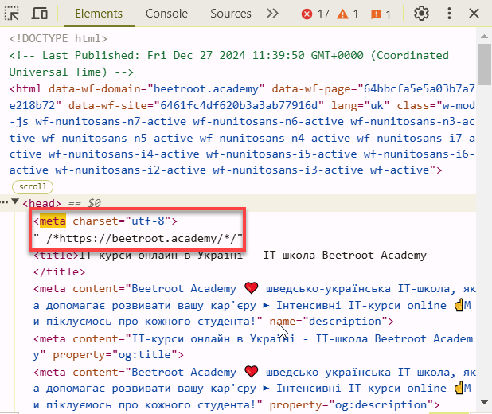

Визначення кодування символів за допомогою Developer Tools на вебсторінці: <https://microseniors76.com/>(ISO-8859-1).

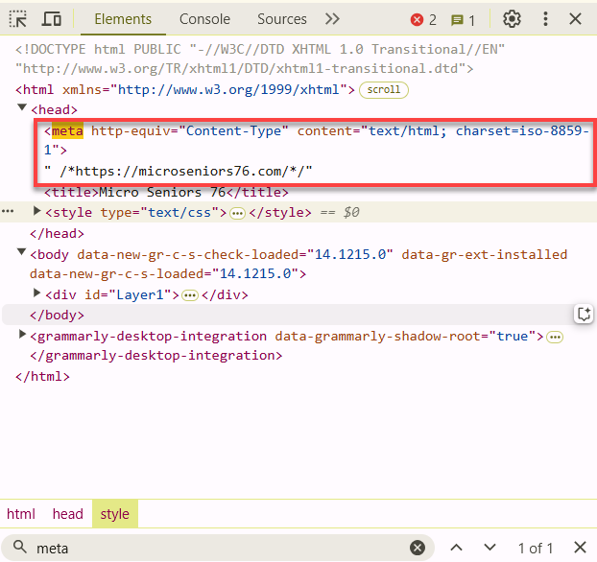

Визначення кодування символів за допомогою Developer Tools на вебсторінці: <https://www.tennis-warehouse.com/> (UTF-8).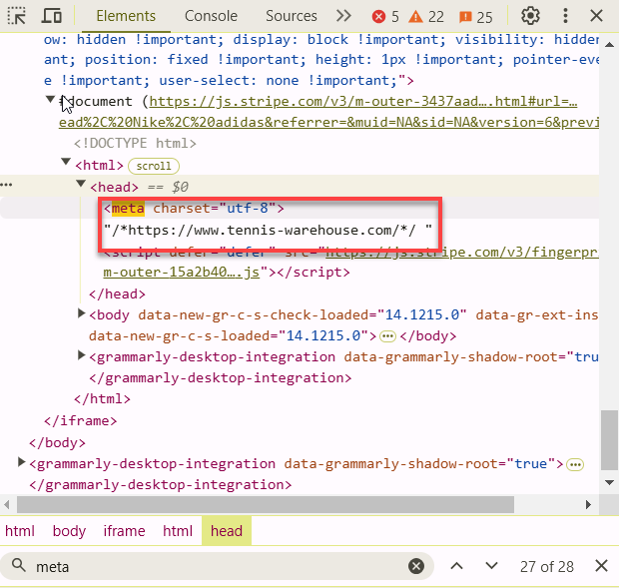

Визначення кодування символів за допомогою Developer Tools на вебсторінці: https://www.fidelity.com/ (ISO-8859-1).

